1. You can’t update information on your profile. It shows an error.  
   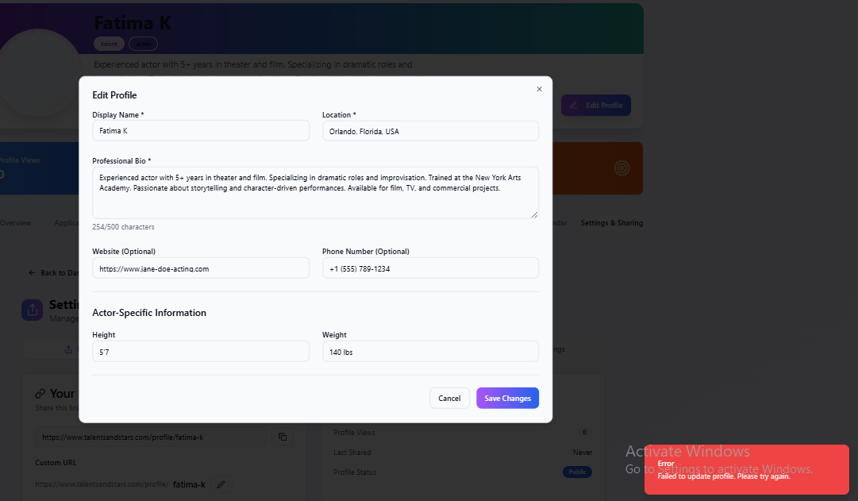
2. The “Preview” option in “Settings and Sharing” leads you to this page which shows that your profile does not exist:  
   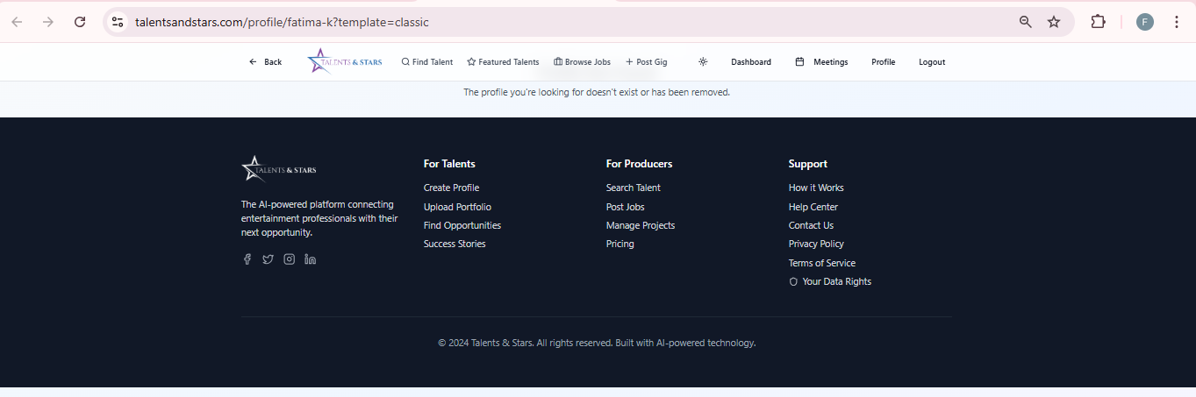
3. There should be a “Save Changes” option here to show that a profile appearance is selected. Even though it tells you that the template has been saved, appearance remains same.

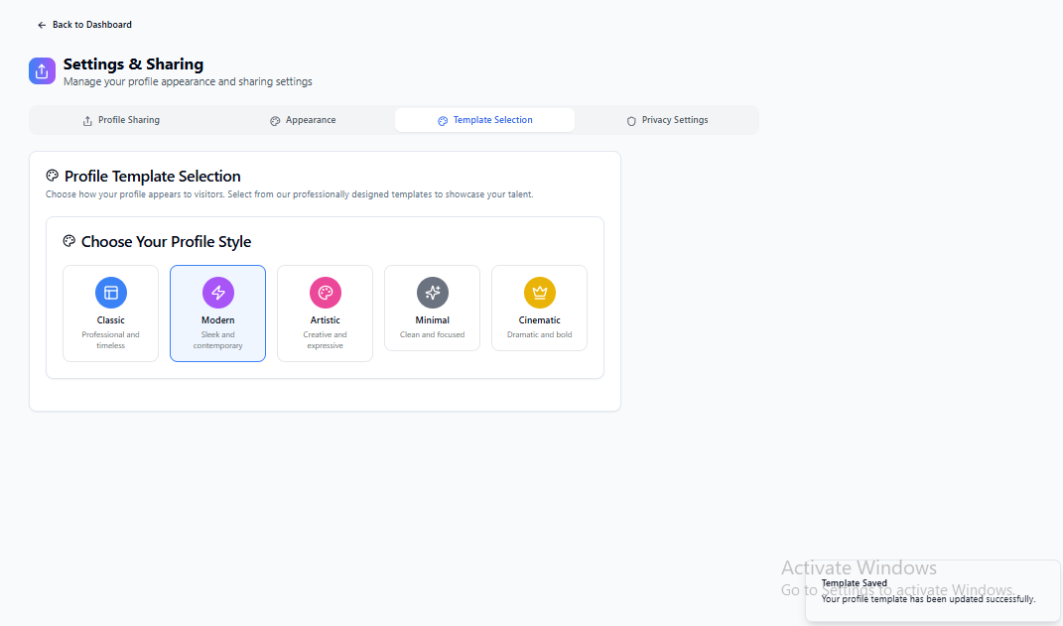

1. "Profile Views" and "Network" stats are static (non-interactive).

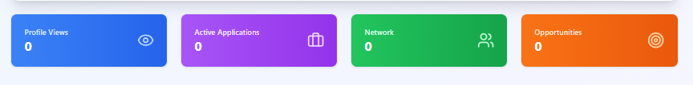

Make both metrics **clickable** to:

* **Profile Views:** Expand to show recent viewers (e.g., casting directors, agents).
* **Network:** Redirect to full connections list.

1. You can add working experience but can’t make changes later on:  
   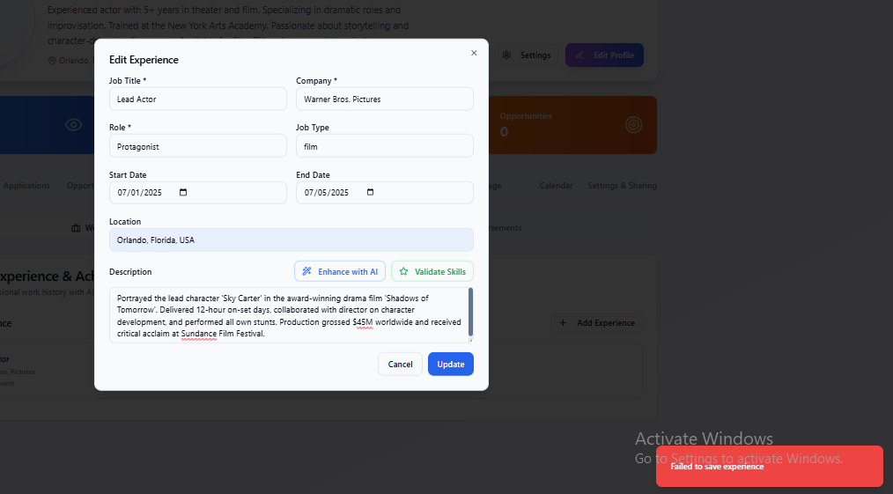
2. The billing process doesn’t work in case you want to upgrade your profile:  
   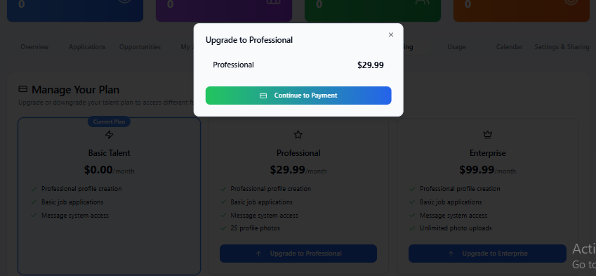
3. The “Filter” and “Search” option under Job Applications doesn’t work:

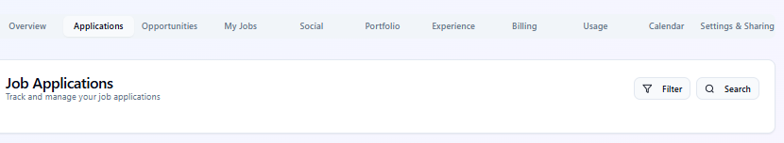

1. You can’t share a post, or a media file to it. It shows an error:  
   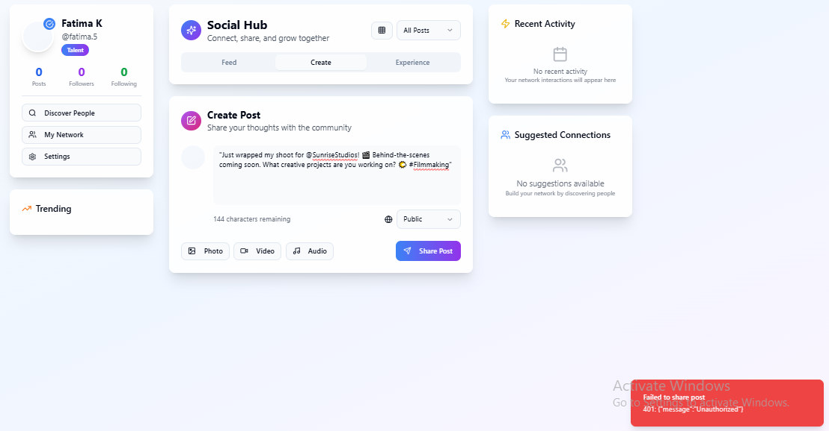
2. Lastly one of the major problems is that it logs you out randomly even if you select “Log Out Manually” option when logging in.